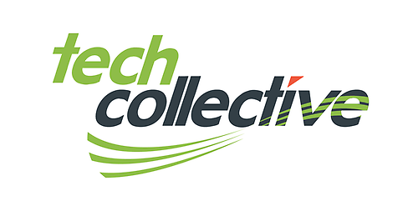
A Discussion on RISK
In a business environment, risk is a complex subject with many sides to consider. CEO's and other business managers are met with multifaceted challenges when it comes to assessing and mitigating risk.
In today’s technology world Bring Your Own Device and The Cloud bring specific challenges. We will be discussing these key areas at the roundtable and considering them in the context of how to build a successful risk management program.
Discussion points for the conversation…
- How do companies manage BYOD ?
- Where should company data be ?
- Is the Cloud an option ?
- How do companies remain current with technological advances, attracting the next generations of employees, while mitigating risk associated with emerging and modern tech ?

